Task 11 : Create Repo in CodeCommit & practice CodeBuild & Pipelines.

1. Code Commit

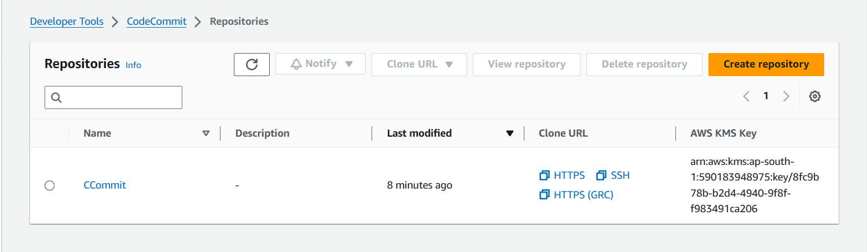

1. Code Build

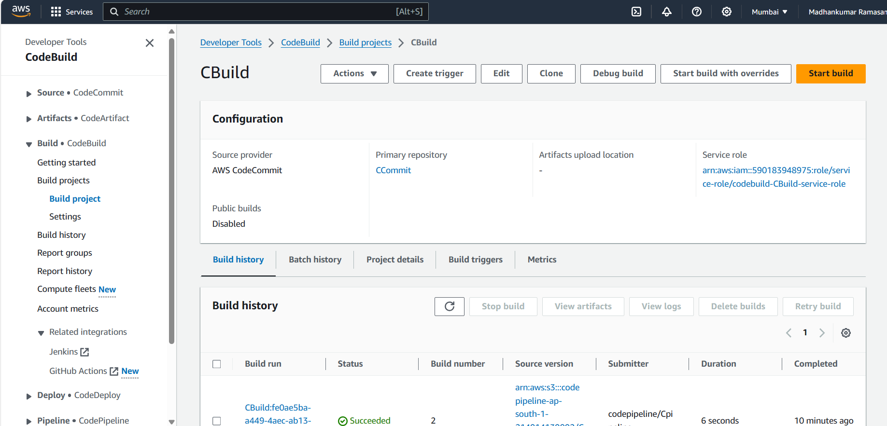

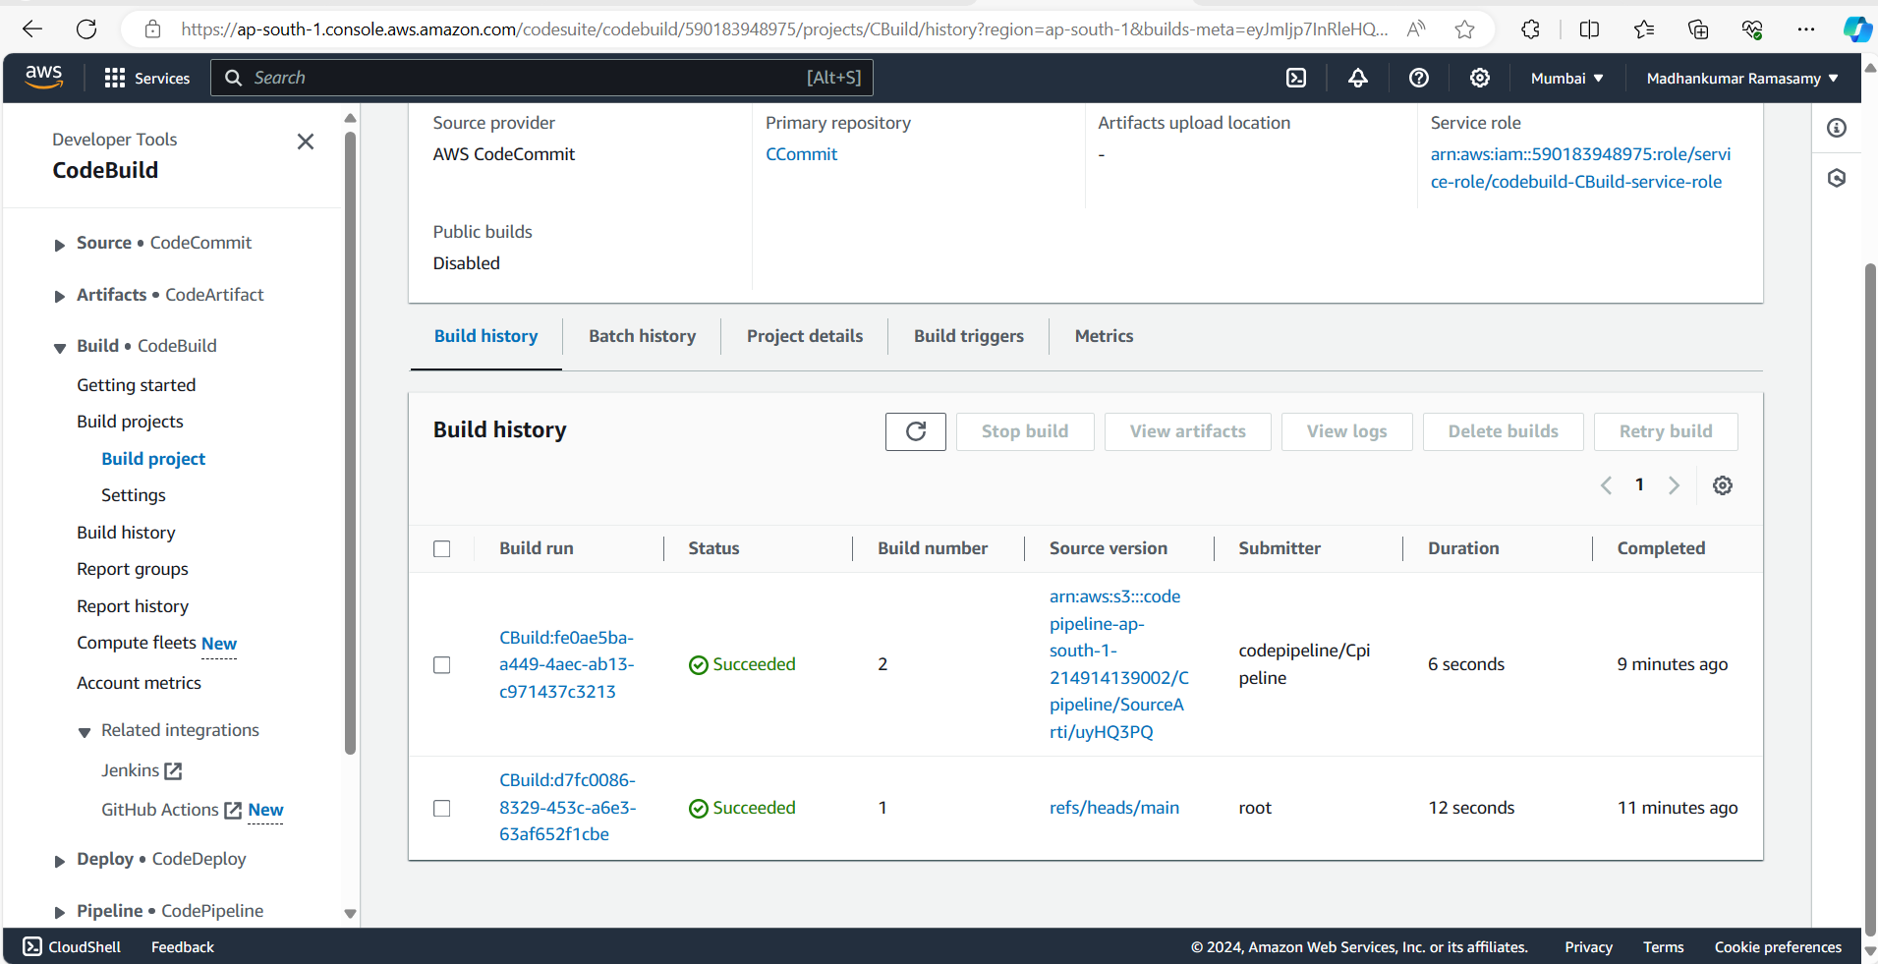

1. Code Pipeline

